Project Development Phase
Model Performance Test

Date | 17 February 2026
Team ID | LVIP2026TMIDSB7385
Project Name | AI Travel Itinerary Generator using Streamlit & Gemini API
Maximum Marks

Model Performance Testing:
S.No. | Parameter | Values | Screenshot
 | Model Summary | This project uses a pretrained Generative AI model (Gemini Flash) accessed through Google Generative AI API.  The model generates personalized travel itineraries based on:  - Destination  - Number of days & nights  - User interests  The model is not trained locally. It is integrated via API and tested using multiple prompt scenarios through a Streamlit web application. | 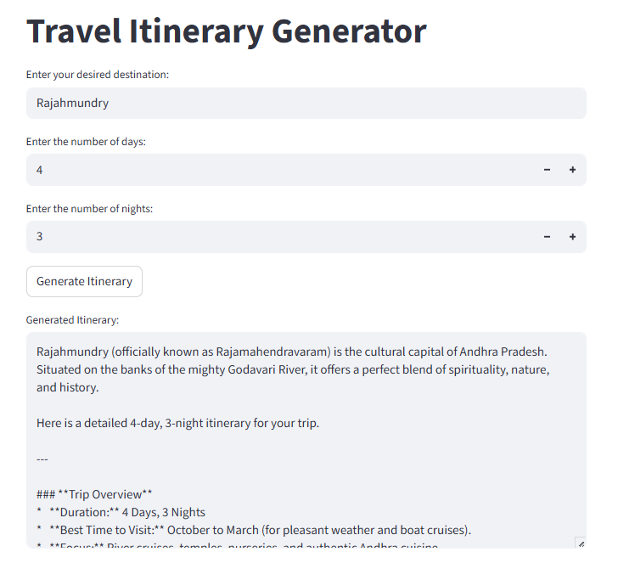
 | Accuracy | Accuracy measured based on output relevance and structure instead of training metrics.  Test Results:  - Correct destination-based plans generated  - Day-wise itinerary structure maintained  - Interests correctly reflected in suggestions  - Multiple test inputs produced consistent valid outputs  Observed functional accuracy: High (manual test validation) | - 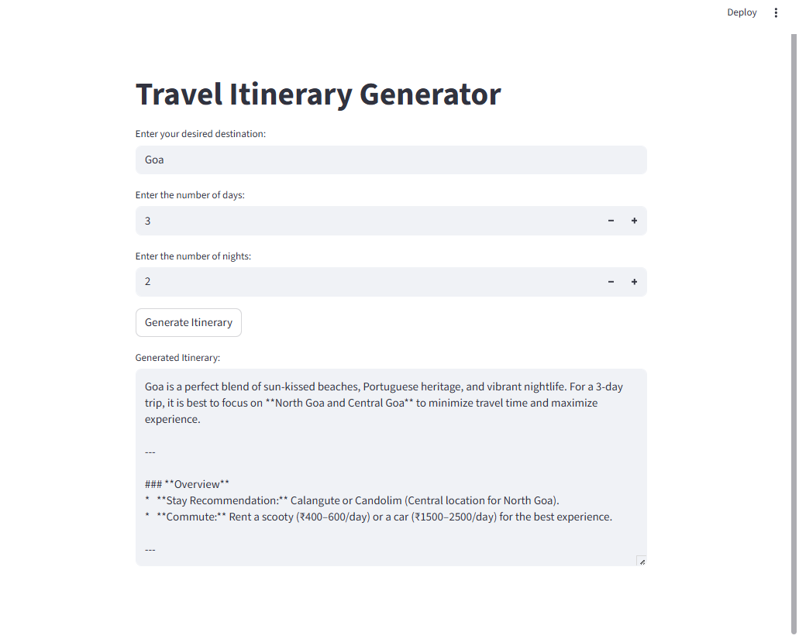
3. | Confidence Score (Only Yolo Projects) | Model responses were tested with multiple different inputs.  Observations:  - Stable response generation  - No crashes during API calls  - Consistent formatting  - Handles varied trip durations  Reliability: High under normal API availability conditions.

